|  |
| --- |
| 8 |
| Nyan Cat – Saving Nyan Balloon |
| **Mini Side Scroller Games** |
| Version 6.0  All work Copyright © 2013 by 8-BITS Games.  All rights reserved. |
| **Excelia Dewi & Harsimrat Kaur** |
|  |



|  |
| --- |
| August 5th 2013 |

**Table of Contents**

1. **Game Overview**
2. **Game Play Mechanics**
3. **Controls**
4. **Interface Sketch**
5. **Characters**
6. **Non-Player Characters**
7. **Enemies**
8. **Scoring**
9. **Sound Index**
10. **Art / Multimedia Index**

**Version History**

*27 July 2013* **Version 1.0**, show nyan cat sprite that can move up and down according to the mouse movement. The limit of the nyan cat motion is based on the height screen of the game. The background is set to 600px as width and 280px as height. There is one basic difficulty level where the Cat has to collect the Balloon Cats and avoid Tac Nyan.

*30th July 2013* **Version 2.0**, Medium level of difficulty added. The user is prompted at the start screen to select their difficulty level by pressing 1,2 or 3 key. For the Medium difficulty, Bonus hearts have been added that grant 1 Life point when collided. There’s two types of enemies now, small asteroids and large steroids. Both taking away 1 life point upon collision.

*3rd August 2013* **Version 3.0**, Hard level of difficulty added. There’s now 3 enemies coming towards you; The Tac Nyan, Small and Large asteroids. Two point collecting sprites have been added, Balloon Cats and Burgers. Balloon cats award 100 points and Burgers award 50.

*5th August 2013* **Version 4.0**, All Glitches resolved and game has been made more streamlined.

1. **Game Overview**

Nyan Cat – Saving Nyan balloon is a mini side scroller game. The game has two state screens, the introduction screens that include the end screen and the actual game screen. The user act as Nyan Cat and has the ability to move the avatar up and down with mouse movement. The situation of the game is Nyan Cat is flying in outer space and has one single goal to collect Nyan balloon. In order to stay alive Nyan Cat has avoid Tac Nyan (Nyan Cat biggest enemy), and Asteroids. Nyan Cat has 5 lives that will decrease one every time he hits any of the enemies. Also, Nyan Cat will gain score one hundred everytime he flying toward Nyan balloon he save Nyan balloon lives by sends him to earth immediately by the magic power of Nyan Cat.

Game has 3 difficulty levels and the game progresses with more enemies and more bonuses with every difficulty level.

1. **Game Play Mechanics**

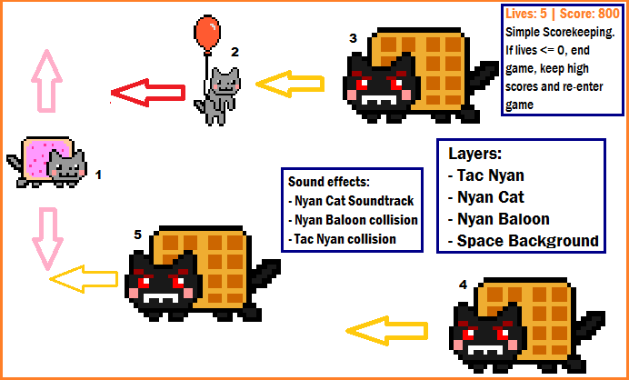

**Index Explanation:**

1. **Nyan Cat**

Mouse controls Nyan Cat to move up and down. Plane stay constant in x but scrolling background and elements give illusion that the Nyan Cat moving forward.

1. **Nyan Balloon/Burgers**

Nyan balloon always moves straight from left to right screen at constant speed. When Nyan balloon hits the left side of the screen it regenerated at random position at top of screen. Player flies over Nyan balloon to gain points.

1. **Tac Nyan Movement**

Each time tac nyan enters the screen it has random y, random drift from down to up and random speed that moves from right to left screen. When Tac Nyan moves off the left of the screen, a new Enemy is randomly generated from the right of the screen.

1. **Enemies colliding with NyanCat**

When enemies hit Nyan Cat more enemies will regenerate randomly at the right of screen and Nyan Cat lives are decremented with each collision.

1. **Bonus Collection**

Heart Sprites grant the Nyan Cat one life point wevery time they collide.

1. **Controls**

The control for the avatar will be the movement of up and down from the mouse.

1. **Interface Sketch**

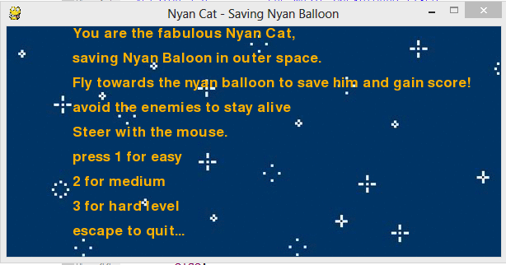

*Introduction State*

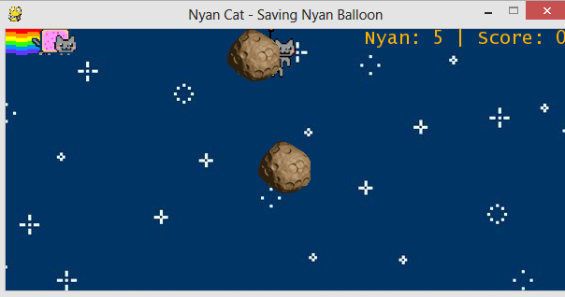

*Easy Difficulty*

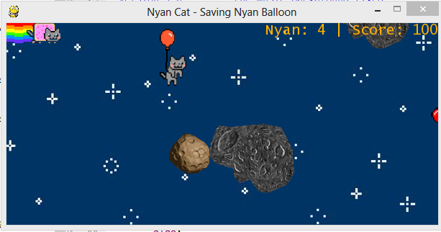

*Medium Difficulty*

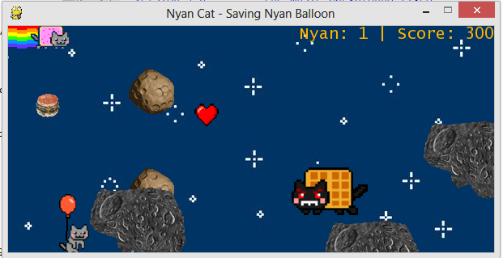

*Hard Difficulty*

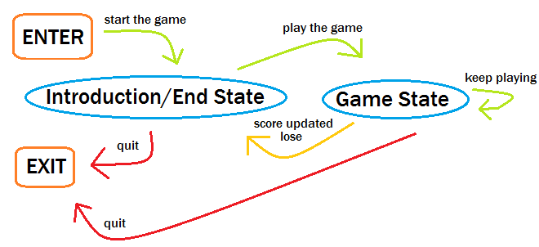

*Nyan Cat State Transition Diagram*

1. **Characters**

The fabulous Nyan Cat is the main character that user has control. He is very famous and viral in the sudden in April 2011 through Youtube video with the trademark of his unique soundtrack and cute look character. Nyan Cat is a flying cat with pop-tart body and always left rainbow mark every time he passed, he spread happiness and peace. In this game he has one mission to save Nyan balloon, once he can flies over Nyan balloon he can sent Nyan balloon immediately to earth by the power of Nyan Cat.

1. **Non-player Characters**

Nan Cat’s buddies are stuck up there hanging on balloons and it’s upto Nyan to save them.

1. **Enemies**

Tac Nyan: The arch-enemy of Nyan Cat.

Small & Large Asteroids: Good idea to avoid colliding into those when you’re flying up inspace.

1. **Scoring**

For each Ballon Cat saved, the player gets 100 points.

For every Burger consumed, the cat gets 50 points.

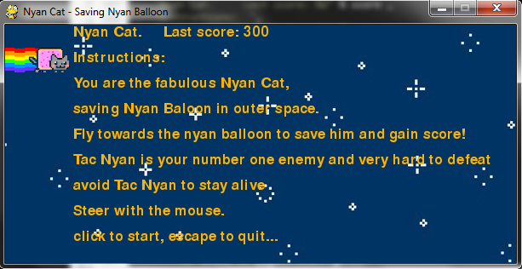

*Last Score get updated*

1. **Sound Index**



*The main sound background, the soundtrack of Nyan Cat*

**

*The sound background when Nyan Cat collide with Nyan Baloon*

**

*The sound background when Nyan Cat collide with Tac Nyan*

1. **Art / Multimedia Index**

*C:\Users\Excel\Documents\Aptana Studio 3 Workspace\Intro To Graphics\Nyan Cat\nyan-rainbow.gif*

*Nyan Cat with rainbow with dimensions 80x32 pixels*

*C:\Users\Excel\Documents\Aptana Studio 3 Workspace\Intro To Graphics\Nyan Cat\nyan-baloon.gif*

*Nyan Baloon with dimensions 40x79 pixels*

*C:\Users\Excel\Documents\Aptana Studio 3 Workspace\Intro To Graphics\Nyan Cat\tac-nyan.gif*

*Tac Nyan using with dimensions 100x62 pixels*

**

*Space Background using .gif image with dimension 1800x400 pixels*

**

*Burger Sprites with dimensions 40x41 pixels*

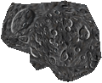

*Large Asteroid Sprites with dimensions 120x98 pixels*

**

*Bonus Life with dimensions 30x30 pixels*

**

*Small Asteroid with dimensions 56x56 pixels*